Miss Barnes Tutoring
SAFEGUARDING FORM

In accordance with Miss Barnes Tutoring Safeguarding and Child Protection Policy, please complete the attached form if you are making a referral about the safety and/or welfare of a child or adult at risk. Please follow the guidance laid out in Miss Barnes Tutoring Safeguarding and Child Protection Policy.
If you need help completing the form, please contact Paige Barnes. Once finished, it should be sent directly to paigebarnes1@hotmail.co.uk.

Your Personal Details
This section should be completed with the details of the person filling out the form.
Name:
Job Title:
Contact Number:
Email Address:

Details of Concern
This section should be completed factually and to the best of your knowledge - do not include your own feelings or assumptions.
Date that you became aware of the concern.
Date that you are completing this form (should be same day).
Name of child or adult at risk.
Age (if known) - if unknown you can put N/A, 'child' or 'adult' - do not guess an age.
How / where did you become aware of the concern? For example, in a school or during an online tutorial, was it something you observed or heard, or was a disclosure made.
What is the concern? Please use factual details only. Use the words that were spoken or written as accurately as you can in quotation marks, if you cannot remember, please do not guess. Where possible, include any questions asked.
Name of person causing concern and their relationship to the child or adult at risk. Leave blank if known of no person allegedly causing harm.
The date of concern alleged to have taken place. Leave blank if unknown or irrelevant.
The place of concern alleged to have taken place. Leave blank if unknown or irrelevant.
If there are visible marks or injuries on the person, please use the map below to circle these and describe what you can.
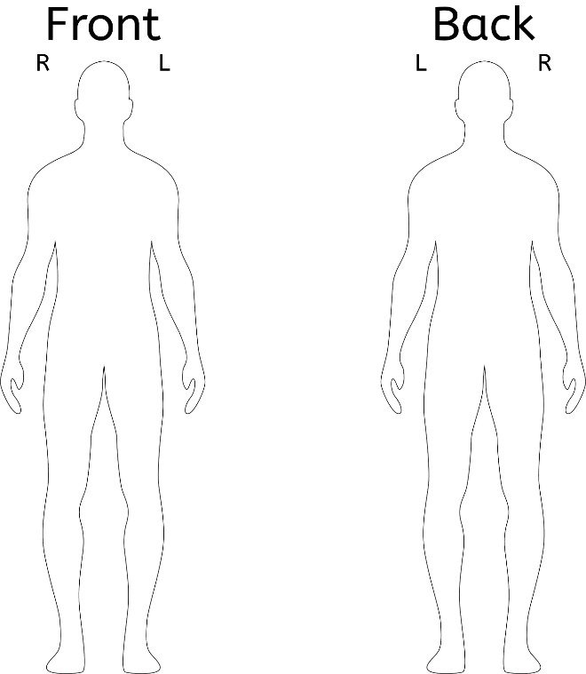
Is there anything else you need to add regarding the concern?

Details of Local Authority Agency/Organisation
Name of Agency/Organisation reported to:
Date and time reported:
How was the referral made (e.g., phone, email, online referral)?
Reference number (if applicable):
Was any advice or action given?
Were any follow-up actions planned by the agency/organisation?
Is there anything else you need to add regarding the referral?

Declaration
By signing and dating this form, you are declaring that:
- you reported the concern to the relevant safeguarding authority, before completion of this form, and;

- you have completed the form above, factually, and to the best of your knowledge and ability.

Name: ____________________________________
Signature: ____________________________________
Date: ____________________________________

For safeguarding team ONLY:
Please sign and date when the form has been received by the team.

Name: ____________________________________
Signature: ____________________________________
Date: ____________________________________

